Project Design Phase
Proposed Solution
Date | 5 September 2026
Student Name | Bantupalli Niharika
Project Name | Automated Network Request Management
Maximum Marks

Proposed Solution
The proposed solution is a ServiceNow-based Network Request Management system. A Network Request Service Catalog item allows employees to submit requests for network-related services such as Wi-Fi, LAN, VPN, and connectivity requirements. The Service Portal provides employees with access to the Network Request functionality.
Catalog variables capture the required request details, while Catalog UI Policies and Client Scripts enforce appropriate form behavior and display relevant fields dynamically. Flow Designer automates the approval process and creates Network Tasks for the Network Fulfillment Team. The system also supports request status tracking and notifications throughout the fulfillment process.
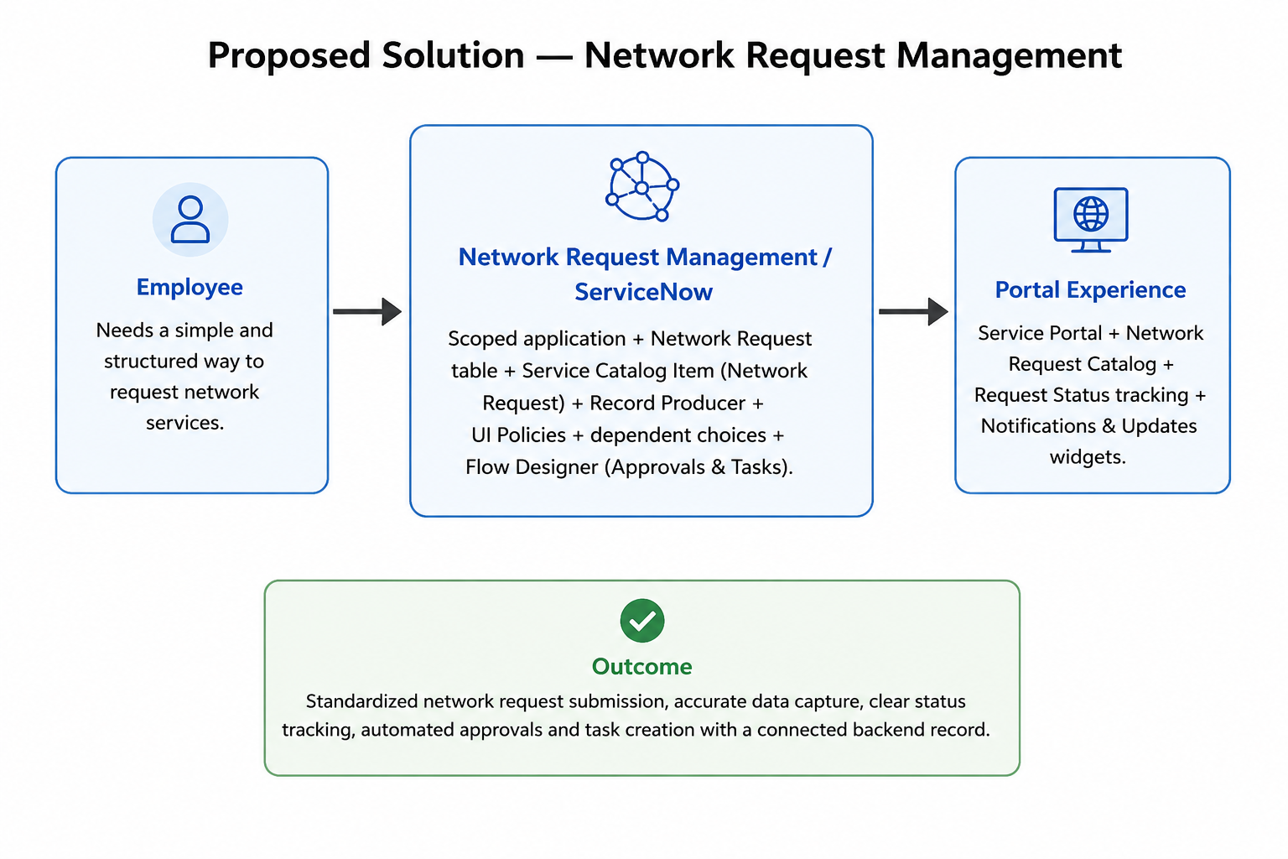

Figure 1: Proposed solution representation.
S.No. | Parameter | Description
1 | Problem Statement | Employees need a simple and structured way to submit network service requests.
2 | Idea / Solution Description | A ServiceNow-based Network Request system using the Service Catalog for guided request submission and automated fulfillment.
3 | Novelty / Uniqueness | Combines Service Catalog, dynamic UI Policies, approvals, Flow Designer automation, and Network Task creation.
4 | Social Impact / Customer Satisfaction | Makes network service requests easier, improves request accuracy, and provides better status visibility.
5 | Business Model / Revenue Model | Internal organizational IT service solution; no direct revenue model is required.
6 | Scalability of the Solution | Can be extended with additional network request types, notifications, dashboards, integrations, and advanced automation.

